Linux
Operating system
- Operating system acts as a intermediate distance between hardware and user.
- Operating system manages hardware in the system.
- And also acts as interpreter

Types of operating system
- Desktop machine:-
It has only used for general purpose like presentation,video games,etc…

- Server machine:-
Whenever multiple user works on the website at same time.it doesn’t affect the user performance because of the system to be created like this called as server machine.

Development of operating system
- Single user single tasking---eg ms-doc
- Single user multitasking
- Multiple user multitasking

What is hypervisor
It is a software that creates space and runs virtual machine like (VMS) etc
We use two operating system at a same time with the help of hypervisor …

Windows
- It is proprietary based
(Means licening is required)
- It is paid
- It is less secure
(Because it gives (read, write, execute) permission)
- It is a closed source.
(We cant change source code)
- It’s a heavy hardware
(To install OS in the hardware you need to give more space)
- It’s a user friendly GUI
- It is a non-portable
- It is a 80% on desktop

Linux
- It is a community based
(means licening is not required)
- It is free of cost
- Is is more secure
(it gives only read,write permission)
- It is open source
- Light weight software
- It is portable
- It is less user-friendly
- It is 90% on desktop

What is interpreter
It is used to translate/converts high level language to low level language called as interpreter.

What is campilar
It is used to translate/converts high level language to low level language called as interpreter.

What is linux
Linux is an open source operating system (OS). An operating system is the software that directly manages a system's hardware and resources, like CPU, memory, and storage.
The OS sits between applications and hardware and makes the connections between all of your software and the physical resources that do the work.

History
- In 1983, american software engineer Richard Stallman started project “GNU project” (means GNU is not unix).
- And in 1985, FSF started (free software foundation).
- In 1991 started programme like debugger,shell,editor.
- But GNU is hard to develop then in 1991 Linus torwards develop kernel.

GNU/LINUX----IINUX Os

Operating systems are…
- Multics
Multics, also known as Multiplexed Information and Computing Service, was a time-sharing operating system developed by MIT, General Electric, and Bell Labs, first released in 1964. Notable developers who worked on Multics include Ken Thompson and Dennis Ritchie.
- UNIX
It is a multiuser, multitasking operating system (OS) designed for flexibility and adaptability. Originally developed in the 1970s, Unix was one of the first OSes to be written in the C programming language.
- BSD
Berkeley Software Distribution (BSD) is a group of related open source Unix-like operating systems (OS) with origins in early versions of Research Unix at Bell Labs. FreeBSD is the most popular member. BSD is configured for internet hosting, web hosting, and hosting many servers on one system.
- Posix
It is a "Portable Operating System Interface for uni-X", POSIX is a set of standards codified by the IEEE and issued by ANSI and ISO.

- Minix
MINIX 3 is a free, open-source, operating system designed to be highly reliable, flexible, and secure. It is based on a tiny microkernel running in kernel mode with the rest of the operating system running as a number of isolated, protected, processes in user mode.

Architecture of OS
- Hardware
- Kernel
- Shell
- Application
- User

OS ----depends on kernel and shell
Kernel ----it is core part of OS
Shell ---it gives input from user
Linux distributions
- Redhat
- Centos
- Mentos
- Fedora
- ubuntu
Root user:-
- It is a super user.
- Home directory of root user is (/root).
- All permission given to a root user

[root@localhost~]#-----prompt
Localhost ---- hostname
Root ------super user
# ------to login with root
/ ------root directory
~ ------home directory
$ ------to login with local

Local user:-
- It is a local user
- Home directory is (/home/username)
- We can create different localuser in linux

Important sites to resolve error
- Stack overflow
- Stack exchange
- Serverfault.com
To switch user
- Home directory—root directory
Su – root

- Root directory----home directory
Su – (username)

File system hierarchy
- /home—Home directory for home user
- /root ---Root directory for root user
- /boot ---Contain bootable files for linux
- /etc ----All configuration files
- /usr ----By default software are intsall in
This directory
- /bin ----Contains command user by all
User including root user
- /sbin----Contains command use by only
Root user
- /opt -----Optional application software
Package
- /dev -----Any other device attached to
System files printers,tty,etc
- Lib----To store architecture information
- /temp--Temporary files by user,system
- /srv-----to store service information
- /var-----logs,mails,webpages,etc
- /mnt----mount point harddisk
- /media--mnt point reader,floopy disk
- /proc----process information
- /sys------system related information
- /run-----runing information

Commands
- hostname------to check hostname
- hostname -i---to check machine address
- Ifconfig -------to check IP address
- which----------to check path
- whoami--------to check who am i
- echo------------to check shell
- grep------------to find out words
- sort-------------to arrange words
- clear------------to clear screen
- echo “$SHELL”----to check shell
- lscpu--------to check cpu information
- lsusb---------to check usb information
- lspci---------peripheral component
interconnect
- free----------to check memory
- free -h ------to check memory in human
readable format
- man----------to see manual page
- info-----------to see information page
- date-----------to check date
- date +%a----to see weekdays
- date +%b----to see month
- date +%c-----to see date and time
- date +%T-----to see time in sec
- date +%t-------to see time
- date -s ---------to change date
- cal---------------to check calender
- cal -y -----------to see year calender
- cal -j ------------to see in julian form
- history----------to see history of command
- tty --------------terminal type show
- who-----to show whos teminal we use and
how many teminals we used
- w------------------load average
- uname-----------to see kernel details
- uname -a--------to see kernel version
- uname -r--------to see kernel version
- shutdown-------to shutdown
- shutdown -c----to cancel shutdown
- shutdown now---to shutdown Immediate
- sudo halt -----to turf off terminal
- sudo reboot -----to reboot the terminal
- dmidecode------to check hardware infor.
to check motherboard.
to check bios informat.
- wc -----------to check words lines characte
- diff ----------to see diff between two files
- df ------------to display diskspace
- alias---------to create custom shortcuts
- pipe---------gives output from first
and input from second
- tee----------show content on terminal as
well as save on file
- tab -------to fill terminal
- ctrl+z -----to stop command forcefully
- ctrl+c -----to stop any command

- How to change hostname permanently
hostnamectl set-hostname (name)

- How to change hostname temporarly
hostname (name)

- How to copy file
cp file /home/mayur/
cp -r file dir1 /home/mayur/

- How to move file
mv file1 /home/mayur/new1

- how to rename file
mv file1 myfiles
Format of change directory
Absolute path
- cd /home/
- cd /root/
- cd /boot/
Relative path
- ./linux/
- ./boot/

How to check files
- ls ----to check list
- ls -l ---to check list with information
- ls -a ----to check hide files
- ls -al -----to check all files include hidden
- ls -ltr ------to check files newly created
- ls -ld ----to check directory
- ll -------to check all files
- pwd ----print working directory
- cd -----change directory

Command line mode / insert mode
(vim /etc/passwd )
- G------curser from top to bottom
- gg -----curser from bottom to top
- yy -----copy line where curser is placed
- nyy ---copy number of lines
- P -----paste line where curser is placed
- p -----paste line below curser is placed
- dd------to delete line where cursor is placed
- ndd -----to delete number of lines
- dw ------delete word
- u ------to undo the word
- O -------to create line above the cursor
- o -------to create line below the cursor
- I --------to beginning of the line
- A -------end of the line
- i --------to enter into insert mode

- w ------to save
- q ------to exit
- wq ----to save and quit
- wq! ----to save and quit
- q! ----------forcefully quit
- set nu ---------give numbers to a lines
- set nonu ------remove number
- /words -------to highlight words
- Nohl --------to removes highlight
- V ---------------to enter into visual mode

Read operation
- Cat -----------to view file from bottom to
top
- Less ----------to view file from top to
bottom
- More ---------to view file from top to
bottom
- Head ---------to view first top 10 lines
- Head -n ------to view numbers of lines
From top
- Tail -----------to view last 10 lines
- Tail -n --------to view numbers of lines
bottom

/etc/passwd
It stores all the information about users
mayur:X:1000:1000:hello:/home/mayur:/bin/bash
mayur--------------username
X ---------------hash form/ encrypted format passwd
1000 --------------user ID
1000 --------------group ID
Hello--------------GECOS
/home/mayur-----home directory
/bin/bash ---------our login shell

Changes in /etc/passwd file
- To add user with a particular UID
Useradd -u 1000 user1

- To add user with a particular GID
Useradd -g 1000 user2

- To add personal information GECOS
Useradd -c “hello” user3

- to add home directory of user
useradd -d /mayur user4
- to add login shell of user
useradd -s /sbin/nologin user5
------------------------------------------------------------/etc/shadow
It stores all the imformation about the passwords in hashed format /encrypted format
Mayur:abcdefgh:18009:0:120:7:14:18759
mayur------------- -username
abcdefgh---------- -hash format password
18009---------------last time passwd change
0 ----------minimum password age
120----------------maximum password age
7 ------------------warning period
14-----------------inactivity period
18759-------------expiration date
1.to change last time passwd
- echo $(($(date +%s)/86400))
18816
- date -s “10 july 2022”
- passwd mayur
- echo $(($(date +%s)/86400))
18817
2.to change minumum passwd days
- chage -l mayur
minimum no of days between passwd change:0
- chage -m 2 mayur
- chage -l mayur
minimum no of days between passwd change:2
- su – mayur
- passwd
you must wait longer to change your passwd

3.to change maximum passwd days
- chage -l mayur
maximum no of days between password change:99999
- chage -M 2 mayur
- chage -l mayur
maximum no of days between password change:2
- su – linux
- su – mayur
- warning:-your passwd will expire in 2 days

3.to change warning period
- chage -W 10 mayur

4.to change inactivity days
- chage -I 20 mayur

5.to change expiration date(account expire)
- chage -E “13 oct 2022” mayur

-------------------------------------------------------------
/etc/group
Tech:X:1021:user1,user2
Tech------------groupname
X ---------------passwd hash format
1021------------groupID
User1,user2----list of members in group
1.to add group
groupadd tech

2.to add group with GID
groupadd -g 1021 tech
3.add no of users in a group
gpasswd -M user1,user2 tech------add multiple
-------------------------------------------------------------
- to add one user in a group
gpasswd -a user1 tech

- to add multiple user in a group
gpasswd -M user1,user2 tech

- to delete user in a group
gpasswd -d user1 tech

- to remove passwd of a user/group
gpasswd -r tech

- to admin a user
gpasswd -A user1 tech

- to remove admin user
gpasswd -A ‘’ tech

- to add user with usermod
usermod -G tech user1
usermod -aG tech user1
/etc/gshadow
It stores all information about group in a hashed format/encrypted format
Tech:X:new:user1,user2
Tech------------groupname
X ---------------passwd hash format
New------------group administrator
User1,user2----list of members in group

1.to add group
groupadd tech

2.to admin a user
gpasswd -A new tech

3.add no of users in a group
gpasswd -M user1,user2 tech------add multiple

------------------------------------------------------

How to remove skeleton files and add also
- cd /home/mayur
rm -rf .bashrc .bash_logout .bash_profile

- su – mayur
[-bash_4.2]$

- cd /etc/skel
cp .bashrc .bash_logout .bash_profile
/home/mayur
- ls -al /home/mayur

- Logout

- su – mayur
[mayur@localhost~]$

Skeleton files are
[ .bashrc .bash_logout .bash_profile ]

Usermod/user modify command
- To modify login shell of existing user
usermod -s /sbin/nologin user1

- To lock the user
usermod -L mayur

- to unlock the user
usermod -U user

- to change userID of existing user
usermod -u 1000 user1

- to change groupID of existing user
usermod -g 1000 user1

- to change groupID of existing group
usermod -g 1000 tech

- to modify name of existing group
groupmod -n tech techy
How to delete users and groups
- For user
rm -rf user1
userdel -r user1

- for group
rm -rf tech
groupdel -f tech
----------------------------------------------------
- how to hide /etc/shadow
pwunconv

- how to unhide /etc/shadow
pwconv

- how to hide /etc/gshadow
grpunconv

- how to unhide /etc/gshadow
grpconv
linux file system security
drwxrwxrwx 3 root root 8118 jul 1 8:31 file1
d---------------------directory
rwx------------------owner
rwx-------------------group
rwx-------------------other
3----------------------link count
Root------------------owner
Root------------------group
8118 -----------------file size in byte
Jul 1 8:31------------time and date
File1------------------file name
1.file type
- Normal file--------------(-)
- Directory----------------(d)
- Link file-----------------(l)
- Block device file-------(b)
- Socket file---------------(s)
- Character device file---(c)
- Pipe file------------------(p)
2.Link count
File ----------------------1
Directory----------------2
Parent directory--------3

Hard-link
- To create a backup file use hard-link
- Its file type is normal file
- Link count increases by 1
- Inode number is same (ls -i)
- Cannot create hard-link of directory
Soft-link
- To create a shortcut file use soft-link
- Its file type is link file
- Link count does not increases
- Inode number is different (ls -i)
- Can create directory as well as file

Metadata
The data that provide information about other data but not the content of data
3.Ownership
- To change group
chgrp root new

- to change owner
Chown root new

- Change both owner and group
Chown root:root new

4.Permissions
Owner--------rwx
Group--------rwx
Other --------rwx
r----------read----------4
w---------write---------2
x----------execute------1

In binary form
rwx ----------111
r-x ----------101
rw- -----------110
r- - -----------100
-w- ------------010
--x ------------001

Binary In octal form
000 0*2^2+0*2^1+0*2^0
001 0*2^2+0*2^1+1*2^0
010 0*2^2+1*2^1+0*2^0
111 1*2^2+1*2^1+1*2^0

5.Default permission
For root
File----------644---{rw- r—r--}
Directory—755—{rwx r-x r-x}
For local-user
File---------664-----{rw- rw- r--}
Directory-----775-----{rwx rwx r-x}

Read--------------ls (long listing)
Write-------------create,delete
Execute----------change directory

6.Full permission
File------------666----{rw- rw- rw-}
Directory-----777----{rwx rwx rwx}

7.umask
umask gives making value of particular default user/permission.
Root---022------default umask
Local—002-----default umask

- For root user /umask

Umask=full permission-default permission
=666-644--------------file
=022

=777-755--------------directory
=022

- For local-user/umask

Umask=full permission-default permission
=666-664--------------file
=002

=777-775-------------directory
=002

- To change umask temporary
Umask (change value)

- To change umask permanently
Vim /etc/profile---------------permanent
Source /etc/profile------------update bash

8.To change permission
u-------user
g-------group
o-------other

(+) -----------to add permission
(-) ------------to remove permission
(=) -----------to replace permission

1st method
- chmod u+x user1
rwx --- ---

2) chmod u=x user1
--x --- ---

3) Chmod ugo=rwx user1
rwx rwx rwx

2nd method
- chmod 777 user1
rwx rwx rwx

- chmod 536 user1
r-x -wx rw-

special permissions
1.suid (super user identification permission):-
it is defined as giving permission to a user to run a file with the permission of file owner.
All users gets access of executable files.
How to apply SUID
Chmod u+s “command”
How to remove SUID
Chmod u-s “command”

Applying SUID,,,
- Chmod u+s /sbin/dmidecode

- ls -l /sbin/dmidecode
rws r-x r-x
2.Sgid (super user group permission):-
This permission can inherient the group property
Group of parent directory inherit with the child directory and files.
- How to apply Sgid
Chmod g+s “directory/file name”
- How to remove Sgid
Chmod g-s “directory/file name”

1st step:-create a group
groupadd cloudblitz
passwd cloudblitz

2nd step:-add member in a group
gpasswd -M user1,user2 cloudblitz
3rd step:-to check the group
tail /etc/group

4th step:-to create directory
- mkdir /project
- ls -ld /project
rwx r-x r-x -----default permission

5th step:-to remove permissions
chmod 770 /project

6th step:-to add group cloublitz in
/project
- Chgrp cloudblitz /project
- ls -l /project
rwx rwx rwx 2 root cloudblitz

7th step:-to add sgid for access the
Cloudblitz
- Chmod g+s /project
- ls -ld /project
drwx rws --- root cloudblitz

8th step:-to create file in /project
- su – user1
- cd /project
- touch sample
- ls -l
rw- rw- r-- user1 cloudblitz new

9th step:-also create file in /project
- su -user2
- cd /project
- touch sample2
- ls -l
3.Sticky bit permission:-
It is basically used for control all other users to resist the delete or modify operation.
Only owners and root user have to access to delete or rename a file.

How to apply sticky bit permission
- chmod o+t “directory name”
How to remove sticky bit
- chmod o-t “directory name”

applying sticky bit permission
- chmod o+t /project
- ls -ld /project
drwx rwx –T root cloudblitz

T-----execution permission removed
t------there is a execution permission
4.Acl permission (access
Control list)
It is special type of permission which is act on a directory and add a extra permission to a directory.
Also denies all other users to use these directory/file called ass acl

How to apply acl for a user
setfacl -m u:(username):rwx /test

How to apply acl for a group
setfacl -m g:(groupname):rwx /test

How to remove acl
setfacl -x u:(username):--- /test
setfacl -x g:(groupname):--- /test

How to remove all acl
setfacl -b /test
How to check acl
getfacl /test

- applying acl…
1st step:-create a user
useradd user1
passwd user1

2nd step:-create a directory
mkdir /test

3rd step:-check the directory
ls -ld /test
drwx r-x r-x ----default permission

4th step:-apply acl for user1
setfacl -m u:user1:rwx /test

5th step:-to check acl
getfacl /test
user:user1:rwx
user :rwx
group:r-x

6th step:-create a file in /test
su – user1
cd /test
touch sample1
ls
sample

To denies all others users permission…
1st step:-to denies other user
Setfacl -m u:user2:--- /test

2nd step:-to see user2 access or not
su – user2
cd /test
ls
Permission denied:cannot see any
Directory

Removing the acl of users from directory
Setfacl -x u:user1:rwx /test

Removing all acl from directory
setfacl -b /test

- apply acl on group
1st step:-create a directory
groupadd tech
passwd tech

2nd step:-apply on group
setfacl -m g:tech:rwx /test

3rd step:-to check acl
getfacl /test

user:rwx
group:tech:rwx
other:r-x

To remove acl on group
setfacl -x g:tech:rwx /test
4.sudo (super user do)
permission
it allows you to temporarily elevate your current user account to a root user/previlage.
means we can use root command as a local user
configuration files
1.vim /etc/sudoers
2.visudo

1st technique:-to do permission with password
1st step:-vim /etc/sudoers
- To search /root in the file and add
Username below that with specific
Path
- Linux ALL=(ALL) /sbin/dmidecode
- wq!

To check permission of /etc/sudoers
ls -ltr /etc/sudoers
r-- --- --- /etc/sudoers
2nd step:-
- su -linux
- sudo dmidecode
- Warning generated
(do not use sudo command) only for root
- Type the password
- And run the command in linux user
3rd step:-
- su – user1
- sudo dmidecode
- user1 is not in sudoers file .this incident will be recorded
4th step:-
- If another user access the sudo file
- these is an error and send a mail to the root user
- to access the sudo file
5th step:-
- You have a mail in /var/spool/mail/root/
6th step:-
- Mail generated in /var/spool/mail/root/
- Vim /var/spool/mail/root/

7th step:-To check direct mail
- Mail

2nd technique:-to do permission without password
1st step:-vim /etc/sudoers

2nd step:-
- Type a path below (same thing without
Password)
- Linux ALL=(ALL) /sbin/dmidecode
- wq!

3rd step:-then go to the linux user
- Su -linux
- Sudo dmidecode
- File will be accessable

3rd technique:-to do permission with wheel group
1st step:-to add user into wheel group
- gpasswd -a linux wheel
2nd step:-
- su – linux
- sudo dmidecode, sudo shutdown,
- all commands get access by only linux user

4th technique:-permission with wheel group (add command into wheel)
1st step:-vim /etc/sudoers
2nd step:-
- Type a path below (wheel group)
- Edit below wheel (all)
- All-----/sbin/dmidecode
3rd step:-
- Su -linux
- Sudo dmidecode
- Access the permission
Filter and search utility
Filter:-it is a program that take plain text as standard output,transform it into a meaningful format and then return as a standard output.
Example:-
- To show no of that line
grep -n root /etc/passwd

- To show how many lines
grep -c root /etc/passwd

- For extended words
grep -E root /etc/passwd

- To show either capital or small
grep -i root /etc/passwd

- To find out words only
grep root /etc/passwd

search:-to search a particular file/directory
1.locate:-
can find a file in database system
updatedb:-
can update file in database system
--------------------------------------------------------
2.find:-
To find out file and related information
Examples:-
- Find / -name mayur

- Find / -user mayur -type d
/home/mayur

If we have to copy all related data of a user
Find / -user mayur -exec cp-rvf ‘{}’ /backup\:
But the owenership be change to (root/root)

If we have not change the ownership
Find / -user mayur -exec cp-aprvf ‘{}’ /backup\:
Archieving
Tar:-it can be used to create,compressed archieves files and also maintain and modify them

Examples:-
- tar -cvf /mnt/etc.tar /etc-------------to create
- ls /mnt-----------------------------------to see file
etc.tar
- du -sh /mnt/etc.tar-------------------to check size
38mb
- tar -xvf /mnt/etc.tar -C /mnt----------to extract
- ls /mnt------------------------------------to check
etc etc.tar
- du -sh /mnt/etc-----------------------to check size
43mb

There are three methods to compress
- gzip (z) ---------------------gz
- bzip2 (j)---------------------bz2
- xzip (J)----------------------xz

1st method :-gzip (z)
- Tar -czvf /test/etc.tar.gz /etc---------compress
- ls /test
etc.tar.gz
- du -sh /test/etc.tar.gz--------------to check size
12mb
- Tar -xzvf /test/etc.tar.gz -C /test--------extract
- ls /test
etc etc.tar.gz
- du -sh /test/etc
43mb

2nd method:-bzip2 (j)
- Tar -cjvf /test/etc.tar.bz2 /etc--------compress
- ls /test
etc.tar.bz2
- du -sh /test/etc.tar.bz2---------to check size
11mb
- Tar -xjvf /test/etc.tar.bz2 -C /test------extract
- Ls /test
etc etc.tar.bz2
- du -sh /test/etc
43mb

3rd method:-xzip (J)
- Tar -cJvf /test/etc.tar.xz /etc------compress
- Ls /test
etc.tar.xz
- du -sh /test/etc.tar.xz---------------to check size
8mb
- Tar -xJvf /test/etc.tar.xz -C /test------extract
- ls /test
etc etc.tar.Jz
- du -sh /test/etc
43mb
------------------------------------------------------------Scheduling
There are three tool for scheduling
- At------------------(non periodic task)
- Cron---------------(periodic task)
- Anacron-----------(desktop task)

At command:-
It is linux-command line utility used to schedule a job for later execution

Steps:-
- At “07:23” -----------take particular time
>touch /task1 --------giving task
>mkdir /dir1 ---------giving task

- Ctrl+D ---------------for save and quit

- Atq --------------------to check task

- ls / -------------------to check files
Task1
dir1

Cron command:-
It is a linux command line utility used to schedule a job to run in the background automatically.

Criteria:-
- Minute
- Hour
- Day of month
- Month (1-12)
- Day of week (0-6) (Sunday 7)
Steps:-
- Crontab -e ----------------------command
* * * * * /bin/touch file1---create
- wq! -----------------------------save and quit
- systemctl restart crond------- to update
- crontab -l --------------------to running task
- ls / -----------------------------to see files
file1
tasks:-
- 10 sept 20:45
- At 7.00am on Monday to Friday
- Perform task only on Saturday
- Every minute
- Every 5 minute
- Every 180 minute
- Every 90 minute
8.For every 4th Saturday
9.Every 2nd Saturday
10.Every hours
11.For 10min and every 2 hour
--------------------------------------------------------
Package management
Redhat family:-
- Low value tool----------rpm
- High value tool---------yum
Debian family
- Low value tool---------dpkg
- High value tool---------apt
Package downloader
- wget
- curl -O
To check package
- rpm –q (package name)
- yum list installed

To check all packages
- rpm -qa
To check information of package
- rpm -qi (package name)
To check information of downloaded package
- rpm -qip
How to download package
1.wget (package name)
2.yumdownloader (package name)
How to install package
1.rpm -ivh (package name)
where i-----(to install)
v-----(verbos)
h-----(hashing)
2.yum install (package name)
How to reinstall packages
Yum reinstall (package name)

How to update package
Yum update (package name)
How to upgrade package
Yum upgrade (package name)
How to unistall packages
rpm -evh (package name)
Yum remove (package name)
Yum autoremove (package name)
How to check provide package
Yum provides (command name)
How to check (search ) package
Yum search (package)

Dependencies:-
One package depend on the other package
Rpm-----it does not download dependencies
Yum-----it download dependencies
How to recover unistall command
Suppose head command unistall and we have to recover these command
- yum provides head
Coreutils-------package of head command
2. yum reinstall coreutils
3. the package has been reinstalled
4. then run the command
5. head anaconda

How to create repository
1.create a directory
mkdir /local
2.then change directory /local
cd /local
3.the download the package
yumdownloader tree
yumdownloader httpd
4.ls
httpd 2.4.6.97 el7 x86.64rpm
tree 1.6.0.10 el7 x86.64rpm
5.to create repository of local
createrepo /local
6.to create configuration file
vim /etc/yum.repos.d/local.repo
1.[abc 123]
- name=local_repo
- baseurl=file:///local
- enabled=1
- gpgcheck=0
7.then save and quit the file
wq!
8.Then yum clean all
9.Yum repolist all
10.yum install httpd

How to diasabled repository
Vim /etc/yum.repos.d/local.repo
- [abc 123]
- Name=local_repo
- Baseurl=file:///local
- Enabled=0
- Gpgcheck=0
2.Then save and quit the file
wq!
3.Yum install httpd
The package install form update not from
[abc 123]
--------------------------------------------------------
Networking:-
It is a interconnected computing device that can exchange data and share resources

OSI model (open system interconnection)
It is a seven layer that computer system use to communicate over a network

Sender side receiver side
1.Application layer 7.Application layer
2.Presentation layer 6.Presentation layer
3.Session layer 5.Session layer
4.Transport layer 4.Transport layer
5.Network layer 3.Network layer
6.Data-link layer 2.Data-link layer
7.Physical layer 1.Physical layer

1st ------three layers are software layes
4th ------is heart layer
Next ---three layers are hardware layers

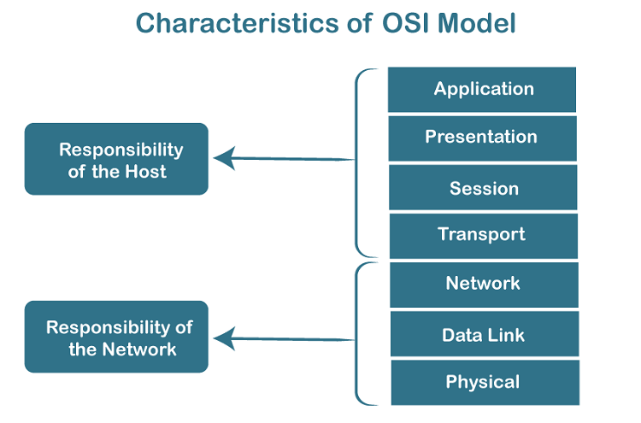
“All people seems to need data processing”

This is a shortcut sentence to learn seven layers
1.Application layer ------end user layer(ssh)
2.Presentation layer ------syntax layer(ssh,ftp)
3.Session layer ------maintain connection
4.Transport layer -----end to end connectin
5.Network layer -----packets ip/igmp/icmp
6.Data-link layer ------frames switch/ppp
7.Physical layer -------physical structure

TCP and IP model
(Tcp—transmission control protocol)
It is a standard that defines how to establish and maintain a network conversation by which application can exchange data. 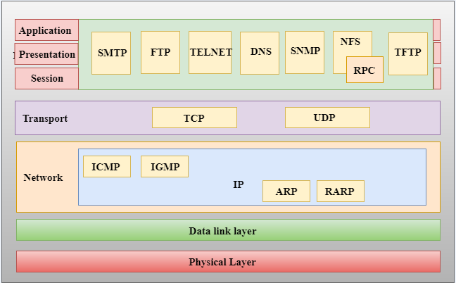

IP (internet protocol)
It is responsible for delivering packets from the source host to destination host by looking at the IP address in packets header

UDP (user datagram protocol)
It is connectionless protocol and used for real-time applications.such as video games, video calls.etc
Example:-video games,video calls

Mac address
- MAC address is the physical address, which uniquely identifies each device on a given network. To make communication between two networked devices, we need two addresses: IP address and MAC address. It is assigned to the NIC (Network Interface card) of each device that can be connected to the internet.
- It stands for Media Access Control, and also known as Physical address, hardware address, or BIA (Burned In Address).
- It is globally unique; it means two devices cannot have the same MAC address. It is represented in a hexadecimal format on each device, such as 00:0a:95:9d:67:16.
- It works on the data link layer of the OSI model.

Why we need mac address
every mac address is assigned to the NIC of a hardware device that helps to identify a device over a network.

Computer network types:-
1.lan
2.wan
3.man
3.pan

1.LAN (Local Area Network)
- Local Area Network is a group of computers connected to each other in a small area such as building, office.
- LAN is used for connecting two or more personal computers through a communication medium such as twisted pair, coaxial cable, etc.
- It is less costly as it is built with inexpensive hardware such as hubs, network adapters, and ethernet cables.
- The data is transferred at an extremely faster rate in Local Area Network.
- Local Area Network provides higher security.

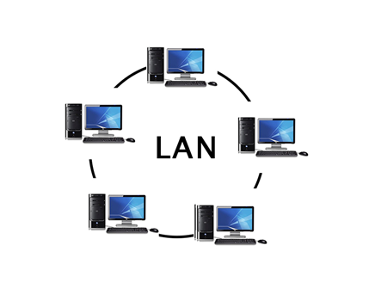
2.PAN (Personal Area Network)
- Personal Area Network is a network arranged within an individual person, typically within a range of 10 meters.
- Personal Area Network is used for connecting the computer devices of personal use is known as Personal Area Network.
- Thomas Zimmerman was the first research scientist to bring the idea of the Personal Area Network.
- Personal Area Network covers an area of 30 feet.
- Personal computer devices that are used to develop the personal area network are the laptop, mobile phones, media player and play stations.
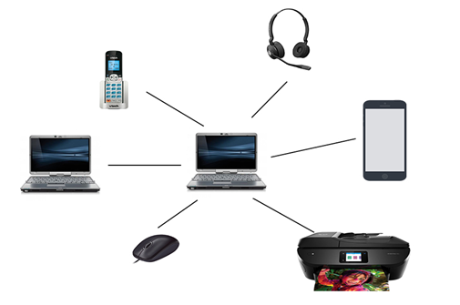

3.MAN (Metropolitan Area Network)
- A metropolitan area network is a network that covers a larger geographic area by interconnecting a different LAN to form a larger network.
- Government agencies use MAN to connect to the citizens and private industries.
- In MAN, various LANs are connected to each other through a telephone exchange line.
- The most widely used protocols in MAN are RS-232, Frame Relay, ATM, ISDN, OC-3, ADSL, etc.
- It has a higher range than Local Area Network(LAN).
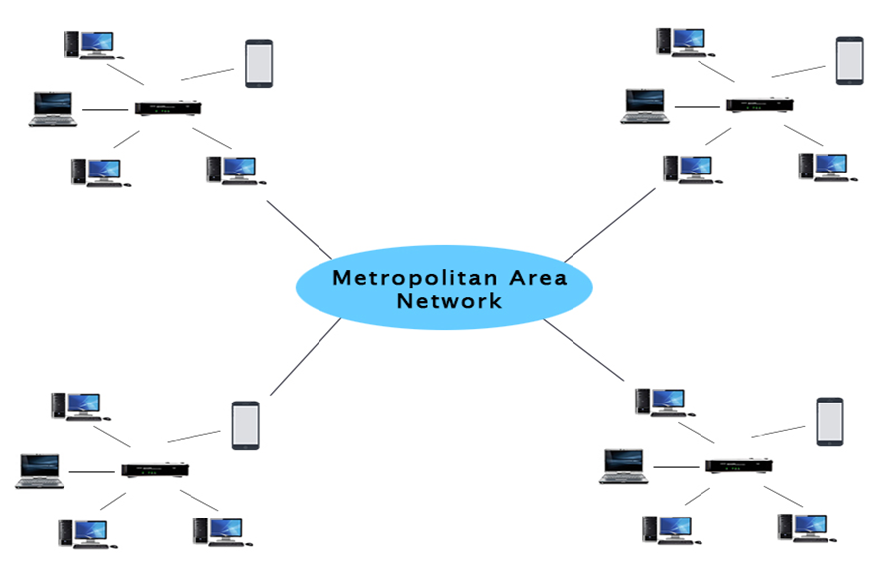

4.WAN (Wide Area Network)
- A Wide Area Network is a network that extends over a large geographical area such as states or countries.
- A Wide Area Network is quite bigger network than the LAN.
- A Wide Area Network is not limited to a single location, but it spans over a large geographical area through a telephone line, fibre optic cable or satellite links.
- The internet is one of the biggest WAN in the world.
- A Wide Area Network is widely used in the field of Business, government, and education.
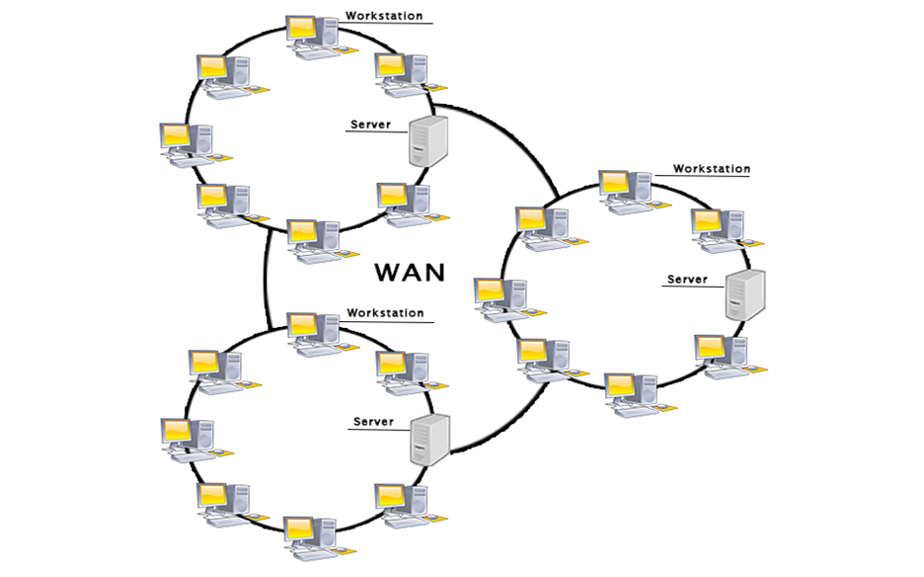

Ip address:-
Physical card------—---mac address--------48 bit
Ip4-----version 4----------------ipv6----version 6
Ipv4----------32 bit
Ipv6----------128 bit
8 bit---8 bit---8 bit---8 bit
Classes:-
0—----126---(n/8)------N H H H =256*256*256
128----191---(N/16)—-N N H H =256*256
192----223---(N/24)----N N N H =256
224----239-------for special task and multitasking
240----255-------reaserches
127----------------Is the system IP or loopback IP

Class A –subnet mask------------N H H H /8
Total no of host =2^n
=2^24
=167777216 host
Subnet mask =255 0 0 0
Class B –subnet mask-----------N N H H /16
Total no of host =2^n
=2^16
=65,536
Subnet mask =255 255 0 0
-------------------------------------------------------------
Class C –subnet mask ----------N N N H /24
Total no of host =2^n
=2^8
=256 host
Subnet mask =255 255 255 0
-----------------------------------------------------------

Networking to connect IP:-
- GUI—------graphical user interface
- TUI---------terminal user interface
- CLI---------command line interface

How to give netmask , host and network

- 192.168.0.44/19

111111111/11111111/1110000/00000000
1.Netmask-----255 255 (2^7+2^6+2^5) 0
-----255 255 224 0
2.Network-----2^3=8
3.Host ------2^12-2=4096

2.172.25.0.5/17

11111111/11111111/10000000/00000000
1.Netmask----255 255 (2^7)
----255 255 128 0
2.Network----2^1=2
3.Host---------2^15-2=3,27,666
3.10.0.0.5/26

11111111/11111111/11111111/11000000
Netmask--------255 255 255 (2^7+2^6)
1.Netmask ---------255 255 255 192
2.Network----------2^2=4
3.Host---------------2^6-2=62
------------------------------------------------------------
4.112.25.0.5/17

11111111/11111111/10000000/00000000
1.Netmask------255 255 (2^7)
-------255 255 128 0
2.Network------2^1=1
3.Host-----------2^15-2=32,766
-------------------------------------------------------------

Private IP range:-
Class A ------10.0.0.0-----10.255.255.255
Class B-------172.16.0.0----172.31.255.255
Class C-------192.168.0.0---192.168.255.255

Public IP private IP
1.internet service decide 1.system admin
IP Decides IP
2.global access charge 2.free of cost charge
3.globally unique 3.locally unique
4.routable on internet 4.no routable on internt
Add adapter / assign IP with GUI
1.we have to add adapter
Setting—network—adapter2---internt network---ok
2.start machine
3.ifconfig
4.enp0s8----assign IP for enp0s8
5.go to applications
6.system tools---setting
7.click on adapter enp0s8
8.click on IPV4
9.IPV4------choose manual
10. address ----192.168.0.4
Netmask—255 255 255 0
Getway-----192.1680.1
11.then apply
12.ifconfig
13.ping 192.168.0.4
Add adapter / assign IP with nmtui
1.we have to add adapter
Setting—network—adapter3---
Internet network---ok
2.start machine
3.ifconfig
4.enp0s9----assign IP for enp0s9
5.type nmtui
6.edit a connection
7.ethernet---add—ethernet
9.profile name----first
Device name----enp0s9
10.IPV4 confi----automatic to manual show
11.address---192.168.0.6/24
Getway---192.168.0.1
12.okk
13.to activate diactivate connection go to the nmtui again
14.activate connection
15.click on first
16.ping 192.168.0.6
Add adapter / assign IP with CLI
1.we have to add adapter
Setting—network—adapter3---internt network---ok
2.start machine
3.ifconfig
4.enp0s10----assign IP for enp0s10
5.on the terminal
6.nmcli connection add con-name demo ifname enp0s10 type ethernet ipv4.addresses “172.25.0.4/24” gw4
“172.25.0.1”
7.nmcli connection show
8.to activate or diactivate the connection
9.ifup enp0s10-----for activate
10.ifdown enp0s10---for diactivate
11.ping 172.25.0.4
Firewall
A Firewall is a network security device that monitors and filters incoming and outgoing network traffic based on an organization's previously established security policies. At its most basic, a firewall is essentially the barrier that sits between a private internal network and the public Internet.

(It is a additional security layer to maintained inbound traffic.)


Systemctl status firewalld
Systemctl start firewalld
Systemctl enable firewalld
If your internet doesn’t work,try to change DNS…
Configuration file…
Vim /etc/resolv.conf
Nameserver 8.8.8.8
wq!
Ping 8.8.8.8-----it works
---------------------------------------------------
Simple way to host webpage
In server machine (172.25.0.4)
1.you have to install httpd
Yum install httpd
2.then configure /create a webpage
Vim /var/www/html/index.html
<h1>
Hello world
</h1>
Wq!--------------------to save and quit
3.to start services
systemctl start httpd
4.also if you have to enable the service
systemctl enable httpd
5.add http service
- Firewall-cmd --add-service=http
Or
- Firewall-cmd --add-service=http --
Permanent
- Firewall-cmd –reload
6.to check the services
Firewall-cmd --list-all
7.To check the webpage
Curl localhost
Hello world
8.also check in firefox
http://localhost
Hello world
In client machine (172.25.0.6)
9. ping 172.25.0.4
10.curl 172.25.0.4
Hello world
11.also check in firefox
http://172.25.0.4
-----------------------------------------------------
Port forwarding
In computer networking, port forwarding or port mapping is an application of network address translation that redirects a communication request from one address and port number combination to another while the packets are traversing a network gateway, such as a router or firewall.
Port forwarding is to reduce the chances of hacking also enhance the security that’s why we use port forwarding

Suppose we have to change the port
1.configuration file
Vim /etc/httpd/conf/httpd.conf
2.Then change listen
Listen80------listen8080
3.then restart the httpd
systemctl restart httpd
4.In client machine
Curl 172.25.0.4
Does not access because we have to change ---the port 80 to 8080
5.In server machine
6.add 8080 Port in firewall
firewall-cmd --add-port=8080/tcp
7.to check the services /port
firewall-cmd --list-all
8.then in client machine
Curl 172.25.0.4:8080
Hello world
9.also check in firefox
http://172.25.0.4:8080
Hello world

10.To change port without knowing
Anyones…
Firewall-cmd --add-forward- port=port=80:proto=tcp:toport=8080
11.To check services/port
Firewall-cmd --list-all
12.go to client machine
Curl 172.15.0.4
Hello world
13.also check in firefox
http://172.25.0.4
--------------------------------------------------------

IP address and masquerade
Masquerade NAT allows you to translate multiple IP addresses to another single IP address. You can use masquerade NAT to hide one or more IP addresses on your internal network behind an IP address that you want to make public.
In centos1 machine (172.25.0.4)
1.You have to install httpd
Yum install httpd
2.then configure /create a webpage
Vim /var/www/html/index.html
<h1>
Hello world
</h1>
Wq!

3.to start services
systemctl start httpd
5.add http service
Firewall-cmd --add-service=http
6.add masquerade
firewall-cmd --add-masquerade
7.then IP forward
Firewall-cmd –add-forward-port=port=80:proto=tcp:toaddr=172.25.0.6

Then centos 2 machine (172.25.0.6)
1.You have to install httpd
Yum install httpd
2.then configure /create a webpage
Vim /var/www/html/index.html
<h1>
This is new page
</h1>
Wq!

3.to start the services
systemctl start httpd
5.add http service
Firewall-cmd --add-service=http
6.add masquerade
firewall-cmd --add-masquerade

then in centos 3 machine (172.25.0.8)
1.ping the machines first
Ping 172.25.0.4
Ping 172.25.0.6
2.curl 172.25.0.4
This is a new page

But if we remove the IP forwarding
Firewall-cmd –remove-forward-port=port=80:proto=tcp:toaddr=172.25.0.6

In centos 3 machine
Curl 172.25.0.4
Hello world

